|  |  |
| --- | --- |
| Name |  |
| Class |  |
| Date |  |

Chapter 6

ICT Applications



6.1 Communication Applications

**What the syllabus says you need to know:**

1. describe a range of communication applications (e.g. newsletters, websites, multimedia presentations, music scores, cartoons, flyers and posters)
2. describe the use of smartphones for communication (e.g. text messaging, phone calls, accessing the internet)
3. describe the use of internet telephony, including Voice over Internet Protocol (VoIP)
4. describe applications for publicity and corporate image publications (e.g. business cards, letterheads, flyers and brochures)

**Lesson Objectives:**

|  |
| --- |
|  |
|  |
|  |
|  |

**Useful links**

www.ictlounge.com/html/communications_applications.htm

[www.igcseict.info/theory/7_1/index.html](https://www.igcseict.info/theory/7_1/index.html)

|  |
| --- |
| Communication Applications |

**Starter**

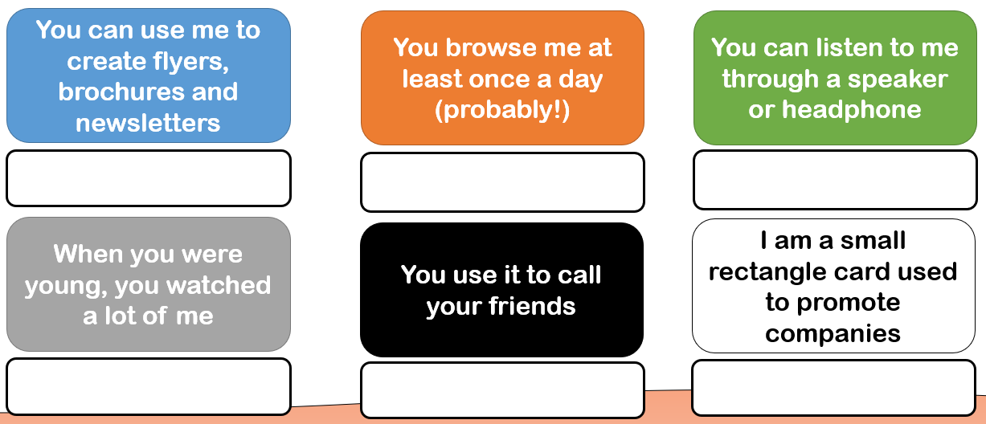

Communication is…

**__________________________________________________________________________**

**Activity: Mind Map**

List all the ways in which you might communicate with someone

Communication methods

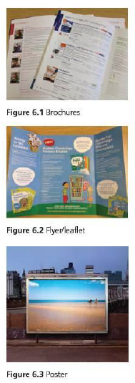





**Extension**

Can you think of **an advantage** of each type of medium?

|  |  |
| --- | --- |
| Medium | Advantage |
| Flyer |  |
| Brochure |  |
| Poster |  |

**Activity: Websites vs. Posters**

**Disadvantages**

**Advantages**

**Activity**

There are other methods of communication in ICT. Complete the word the find out the method, then write about them below using full sentences.



Name of method: M_____________Presentation

A short description

|  |
| --- |
|  |
|  |
|  |

|  |  |
| --- | --- |
| Advantage | Disadvantage |
|  | 1. |
|  | 2. |



Name of method: C __ __ __ __ __ns

A short description

|  |
| --- |
|  |
|  |
|  |



Name of method: Mu __ __ __ Sc __ __ __ __

A short description

|  |
| --- |
|  |
|  |
|  |

**Activity: Mobile Phones vs VoIP (Essay Style Question)**

Compare each method of communication then write a possible advantage and disadvantage for each.

|  |
| --- |
|  |
|  |
|  |
|  |
|  |
|  |
|  |
|  |
|  |
|  |

**Activity**

Business Cards and letter head have many uses in the corporoate industry. List 5 potential reasons a company might use a Business card or letterhead and justify you reason



**Extension**: Mr Jones is setting up a new business called “Jones’ Motors”, which will be selling second hand cars. He has come to you to develop a new business card for him. Design it in the space provided below. Remember to include the important information

Name of company

Contact details

Image/logo

|  |
| --- |
|  |

**Plenary: Matching**

Match the keyword with the description

|  |  |  |
| --- | --- | --- |
| Cartoons |  | A presentation that uses animation, video and sound or music to create a more interesting experience |
| Business Cards |  | Printed media with text and images used to advertise a company, product or brand |
| Music Scores |  | Communication via the internet using VoIP telephones |
| Multimedia Presentation |  | Small cards used to advertise a company |
| Internet Telephony |  | Small hand held devices that communicate by connecting to cell towers |
| Mobile Phones |  | An online shop or advertisement space used to advertise worldwide |
| Brochures and Flyers |  | The use of sound to advertise a product |
| Websites |  | Animated objects, either hand drawn or computer generated |